

OUR JOURNEY SO FAR...

March 2025

NEWSLETTER

THORNER

COMMUNITY

FUND

WHAT WE DO……
Each year Festival Republic provides a number of residents weekend tickets.
Thorner Community Fund also pays for a minibus to take Thorner residents and their guests safely to and from the festival.
Thorner residents are invited to register to receive these tickets with a set donation being made to Thorner Community Fund.
The proceeds from the donations of these tickets goes into the Thorner Community Fund.
It is our role to administer the distribution of resident’s tickets in a fair, transparent way for the benefit of Thorner residents and to manage and facilitate monetary grants to Thorner groups and societies to maximise benefit to the wider Thorner community.
WHO WE ARE:
- Wayne Young - Chair
- Zoe Staines - Secretary & External Communication
- Rob Arthurs - Finance
- Mark Darley - Oversight & Scrutiny
- Katie Coppock – Ticket Distribution List & Data Management
- Sheila Llewellyn - Grants
WHAT WE HAVE DONE IN THE PAST……
Between 2003 and 2018 we have benefited 35 Thorner groups, providing funding of around £515,000 through a combination of ticket donations and personal funding from Melvin Benn in support of Thorner and its community.
This included items such as new equipment, waterproof electrical equipment, new toys, refurbishment projects, training costs, tutorial fees, venue rentals, decorating costs, damproofing to storage rooms, new furniture, conversions and upgrades of buildings, drainage to outfields, ride on mowing equipment, gazebos, camping equipment, computers, refurbishment of the church clock, pump refurbishment on Sam Sykes, provided a running track for Thorner Primary School and music tuition which was an on running item over several years. Many more projects were awarded grants such as Thorner Tree Group “A tree for every home programme”
We have also funded emergency repairs such as leaking roofs, a new boiler for St Peters Church and remedial work following flooding to the bowling green and its clubhouse.
During 2017/2018 having invested a significant amount of funding within the village, the long-term value of grant bids was reducing, and requests were increasingly becoming focussed on running costs. So, in discussions with Melvin Benn, Thorner Community Fund refocussed its funding strategy to build up a reserve to fund a more significant, multi-year investment which would deliver real benefits, and make a huge difference with long lasting effects for Thorner and its community, such as moving in the direction of sustainable, environmental projects that would help Thorner reduce its Carbon Footprint.
Melvin Benn, Festival Republic: “It would be fantastic if we could make Thorner Carbon Neutral”

In 2019 Covid hit us all hard and due to shielding and lockdown no grants were awarded, Leeds Festival was cancelled resulting in no funding that year.
During 2020 and the pandemic “Feed the Need” was set up by a group of volunteers within the village. The group was funded for eco-friendly food packaging and fuel costs for volunteers to deliver a hot meal to the vulnerable.

SEE WHAT HAVE WE DONE SINCE THEN…….
Our planet is trying to tell us something, for the past four years at every turn of our calendar “the heat has been turned up” In May 2024 it was the hottest temperatures recorded over Europe.
Within Thorner itself we have seen more severe storms and more flooding resulting in damage to some resident properties.
We are facing a Climate Crisis – a situation characterized by the threat of irreversible changes to the global climate.
Some village community buildings are facing a dilemma. Soaring energy bills are threatening the future of these vital spaces. Many groups running these buildings feel overwhelmed by rising costs and building maintenance challenges which they can feel ill-equipped to deal with. Many community buildings want to make their buildings work better for them – including improving how energy efficient they are and with support from external bodies they have transformed their building spaces, ensuring they continue to serve their communities whilst contributing to their net zero climate goals (Monk Fryston and Hillam villages are an example of this noted below)
How can the longevity of Thorner community buildings be ensured given their varied states of condition? these community buildings are a lifeline for some of our Thorner residents.
Thorner Community Fund was then contacted by The Bungalow Secretary due to problems with a leaking roof, the building was also cold and draughty and energy bills were soaring. They applied for an emergency grant to support the roof repair costs, but it was evident that additional work was necessary to ensure the building was watertight.
During further discussion it became apparent that it was not going to be “a quick fix” to make the building fit for purpose and to continue to provide a vital service to the community it also became apparent that other Thorner Community Buildings were also facing similar challenges.
- How can community groups keep their buildings running for generations to come?
- How can community buildings be more sustainable for the future?
- What steps could be taken to reduce their carbon footprint whilst saving energy costs?
With these questions in mind, a Sustainability Working Group consisting of Thorner Community
Buildings Leaders, some Thorner residents and Ward Councillors was formed alongside
Thorner Community Fund to help them facilitate a process towards becoming more sustainable,
reduce their carbon footprint thus reducing energy costs.

Other villages have been successful in becoming Carbon Neutral such as Monk Fryston and
Hillam.
Their project was about the residents wanting to try to cut their greenhouse gas emissions to
improve the environmental performance of their five community buildings and hopefully point the
way for other villages to follow suit. The Working Group took the opportunity given to meet with the
project leaders to lead us on the right pathway and they gave some very useful information to do
so. Look at their success story: www.mfhcc.com
Based on a recommendation from a Thorner resident, the Working Group met with Professor Brown and Professor Ryan, both Professors are involved in projects that train and research PhD students to become future sustainability professionals.
Professor Ryan suggested a heat network may be something we could think about dependant on water and land. Professor Brown explained that a heat network pump could be installed to the whole village with a loop system to each house and would heat water as needed replacing every boiler in the future. Professor Brown stated that it understandably needed significant investment and the whole village would need to participate.
Professor Ryan suggested this project would be ideal for a PhD engineering student to undertake.
It would take about three and a half years, including six months of preparation, and would cost
around £150,000, excluding implementation and funding costs.
This would be a big leap for the village and had gone from initial thoughts of Community Buildings to the whole of the village. If this were to be considered for the future, Landowners and Farmers permission and involvement would be needed, along with the whole village participating and taking full ownership of the project.
AND SO, THE JOURNEY CONTINUED……
We continued to work alongside the Working Group to help them to achieve their goals and facilitate them towards becoming sustainable, carbon neutral, thus reducing the carbon footprint and reducing energy costs and these buildings are:
- Thorner Victory Hall.
- Parish Centre.
- Over 60’s.
- St Peters Church.

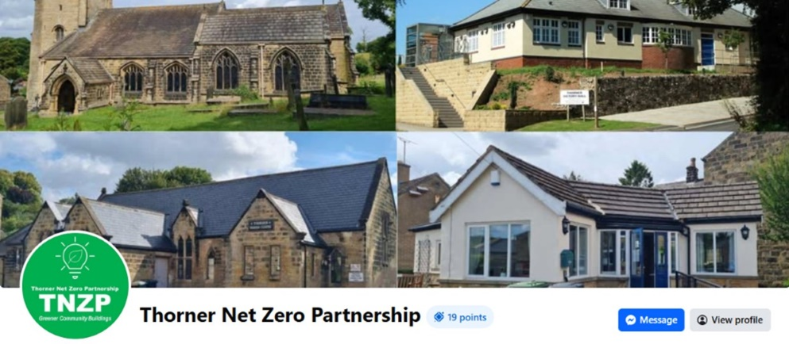
A website was created Thorner Net Zero Partnership which is operated by the Working Group and is available on Facebook. The website aims to showcase the results and experiences from each partnership project venue, providing practical examples of carbon reduction and cost savings and identifying areas of energy waste.
It was recognised that the Community Buildings needed to get their buildings watertight as a starting point.
In July 2023 the Working Group appointed D3 Associates, Energy and Architecture to undertake a Sustainability Assessment on all four buildings this was funded by Thorner Community Fund and resulted in a comprehensive Decarbonisation Report and a recommended programme of all works and upgrades for all four buildings.
The main priorities of the report were:
Phase 1.
- Energy demand should be reduced as much as possible, identify where energy is wasted.
- Improve the building fabric and insulation- make the buildings watertight with simple low-cost measures such as draught proofing, roof insulation and double glazing.
- Cavity wall insulation where required.
- The replacement of halogen bulbs and fluorescent strip lights to efficient LED lighting.
Phase 2.
- Heating and electricity should come from the lowest possible carbon source, ideally removing fossil fuel boilers and replacing with electric heating such as biomass heaters, ground source heat pumps and air -source heat pumps.
- Solar photovoltaic systems to capture energy from sunlight.
- Generate renewable electricity on site to match demand as much as possible.
- Control systems and energy management to reduce the overall demand whilst the deployment of appropriate renewable energy generation will reduce the carbon footprint.
Each building has a copy of the report outlining the recommendations of the report, and it is these recommendations that they are working towards.
Sustainability, Biodiversity and environmentally focused projects are now at the centre of the grant strategy, recognising the importance of protecting our environment and natural resources.

During 2023/2024 the Working Group started their first steps along the path as recommended in the Decarbonisation report. These are the grants that were awarded during this time.
- Funded D3 associates decarbonisation and sustainability report -£6,500
- Thorner Bowling Club emergency roof repairs and insulation - grant awarded £2,000
- The Over 60’s emergency roof repairs to their leaking roof – grant awarded £600
- Provided free water butts and compost bins to house owners that wanted one – still ongoing – cost of £4,582.
- The Over 60’s replacement of external rendering, replacements of soffits, fascia boards to make the building watertight and help with insulation – grant awarded £7,270. This completed Phase 1 of our sustainability project in October 2024.
- Thorner Victory Hall, match funded installation of solar panels and batteries – grant awarded £10,000.
Thorner and its community have been awarded approximately £545,000 in funding from the onset of the fund to the present time.

NEXT PART OF THE JOURNEY……
The Working Group will be looking at the next phase of the project in Spring 2025.
The Over 60’s will focus on looking towards Phase 2 as recommended in The D3 decarbonisation report.
The Parish Centre and St Peters Church are still within Phase 1 and have been very busy actively seeking grants other than from Thorner Community Fund. The Parish Centre has since been successfully awarded £30,000 from external grants and can now commence Phase 1.
The diocese of St Petres Church has since conducted their own sustainability assessment and agreed that the work completed by D3 Associates ties in with their own net zero policy. assessment. They both hope to fulfil the recommendations set out within their reports.
They will continue with this work and Thorner Community Fund will facilitate as much as we can.
Thorner Victory Hall will focus on Phase 2 and look at alternative system for heating such as Air to Air or Air to Water systems saving energy, money and carbon emissions.

Thorner Community Fund have requested that building managers refine their plans for phases 1 and 2 as outlined above and they will shortly be updating their projected costs and time scales.
Thorner Community Fund recognises that this community project may entail significant expenditure and is preparing for potential funding requests. It is anticipated that completing all the outlined work would surpass the current funds available to the Thorner Community Fund.
We have consistently advised all groups and societies to pursue other alternative funding sources and additional grants when applying to the Thorner Community Fund. This approach ensures that the fund's resources are not excessively committed and allows for the consideration of other applications from the village.
Thorner Community Fund will continue to support grant applications from village groups and societies. If necessary, the Fund will underwrite these applications in cases where external funding or grants are pending or have been unsuccessful, provided that the current criteria are met.
The Sustainability Group continue to seek alternative grants and funding through the Thorner Community Fund Criteria to support their project. They have been awarded more than £20,000 from external grant sources so far.
Thorner Community Fund continue to Provide “EMERGENCY FUNDING” to the village where needed. Your application will be considered based on the information given.
EMERGENCY FUNDING WILL BE GIVEN PRIORITY- We aim to respond to your application quickly.
- This could be emergency repairs to enable groups and societies to keep running and to continue servicing the village such as roof repairs or building repairs.
- Unplanned or crisis situations which prevent your group from functioning and servicing the village.
We do encourage other groups and societies within the village to join us on the journey and welcome any new applications based on our current criteria.
APPLICATION PROCESS.
Informal enquiries are welcome, and we are happy to discuss this with you. Application forms for grant applications/emergency funding can be obtained from: thornercommunityfund@gmail.com

TESTIMONIALS.
FROM OCTOBER 2024 OVER 60’s NEWSLETTER:
“You can’t fail to notice that the exterior of the bungalow is now looking much smarter than a year ago. The rendering is now on complemented by new lights and a smart new post-box. Plus, we now have new windows, doors soffits, facias, gutters, drainpipes and water butt. Many thanks to Thorner Community Fund for paying for the soffits, facias, gutters, drainpipes water butt and rendering which will help to keep the building warmer and drier, reducing our energy consumption.
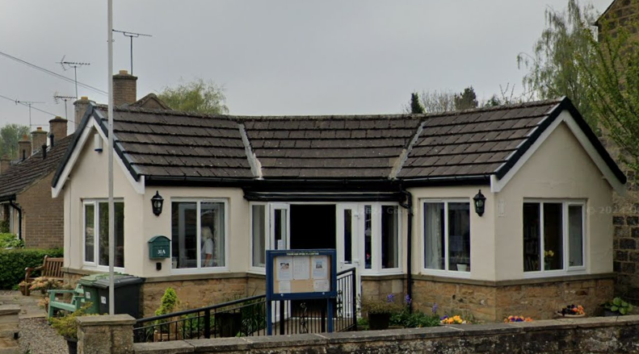
Phase 1 of our energy reduction programme is now complete. Together with the Parish Centre, the Victory Hall and St Peter’s church, the Over 60’s is part of the Thorner Net Zero Partnership. This started with an energy survey of the buildings paid for by the Community Fund and each of the buildings like us are on their way to reducing our carbon emissions”
“Amazing progress from the first meeting and I know everyone will be pushing for more to be done but given where we were, it’s a huge credit and congratulations to all involved” Councillor Matthew Robison (Harewood Ward).

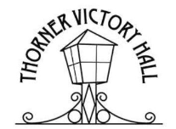
THORNER VICTORY HALL
“Further to the commissioning of the D3 report, The Victory Hall has also taken part in the ‘National Buildings Database’ project, organised by the Department for Energy Security and Net Zero. This provided us with another audit report and recommendations for energy efficiency improvement, and feedback from the auditors was extremely positive.
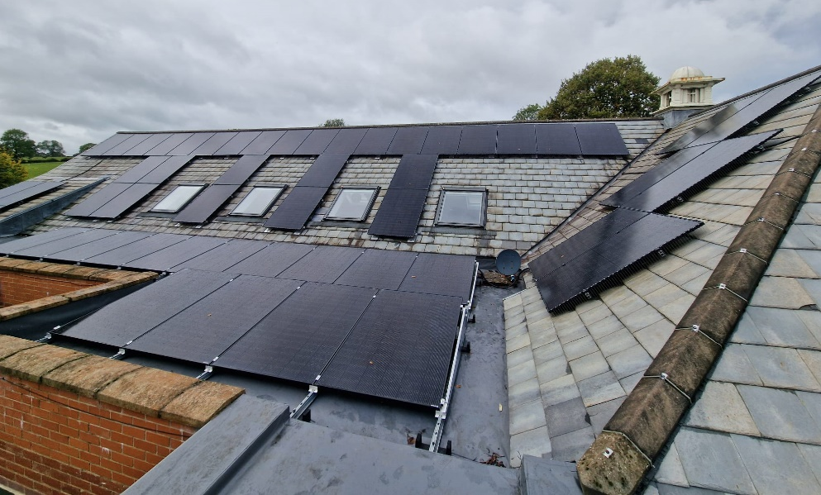
The Victory Hall has in recent years improved roof insulation and replaced ageing windows with double glazed units (this work continues). Lighting has been upgraded, and all these measures have had a demonstrable impact on electricity consumption. Our ultimate aim is to minimise dependency on non-renewable fuel, replacing the gas fired boiler with air source heat pump(s).
Our energy audits identified that the installation of solar panels and associated battery storage would be a practical ‘next step’ towards that aim. Our existing gas boiler is still serviceable but when replacement is due and installation of a heat pump system becomes a viable alternative, the solar panels would mean we would have sufficient solar-generated electricity to power it.
We applied to Thorner Community Fund for a contribution towards the cost of installing a photovoltaic (solar panel) system with battery storage. They agreed to ‘match’ our own funds raised by events such as the Comedy & Beer festivals, and live music events. Our system was installed in October 2024.”
“Our estimated annual electricity bill savings are £1,935. In the first 3 months of operation (not the sunniest time of the year!), the system generated 2.21 MWh of electricity, saving 432kg of CO2 emissions - the equivalent of planting 26 trees.”
CONTACT US.
- email: thornercommunityfund@gmail,com
- Informal enquiries welcome.

